**Developer report (Times New Roman, Font Size-16, Bold)**

**Title**

**Title ID**

**Objective of the project:**

**Development Procedure,**

**(Heading: Times New Roman, Font Size-12, Bold)**

(Normal Text: Times New Roman, Font Size-12**)**

**Execution Procedure,**

**Reference Link,**

**Trouble Shooting**

**Output Screen shots**

**Extension Idea**

**Note:**

* Page Layout: Top, Bottom, Right: 1” Left: 1.25” , Orientation : Portrait,

Page Layout- Size- A4, Alignment: Full page Justify, Line Spacing – 1.5

* Header: Domain- right, center - Logo and Technology - left (Cambria – 12)
* Footer: Address (Cambria – 12- center alignment)

**DEVELOPER REPORT**

**Title: EMOTION RECOGNITION AND DETECTION**

**Title ID: -----**

**OBJECTIVE OF THE PROJECT**:

The main goal of this project is to develop a model which will detect and recognize the facial expression of the person. Based on his/her facial expression we can detect their emotions and how they are feeling in that situation.

**DEVELOPMENT PROCEDURE:**

* Gather the requirements like dataset from Kaggle.
* Install and import packages.
* Pre-process the dataset.
* Build the required models for further process.
* Fit the data in the model.
* Get accuracy from the model.
* Predict whether the given input image or video stream has any emotions on the persons face.
* Represent the results using webcam in live.
* It will detect and recognize the person who is in front of webcam. He has any emotions in his face or not.

**EXECUTION PROCEDURE:**

* Completion of your development click on run.
* Your code will get execute
* And you will get a link in your terminal window, click on that it will open your application in web.
* Execute the application as it has the flow.

**RESULT AND DISCUSSION:**

Here in this project we going to detect and recognize the facial expression of the persons in the different situations. Our model will detect and recognize the facial expressions of the persons in images also and live in video stream accurately.

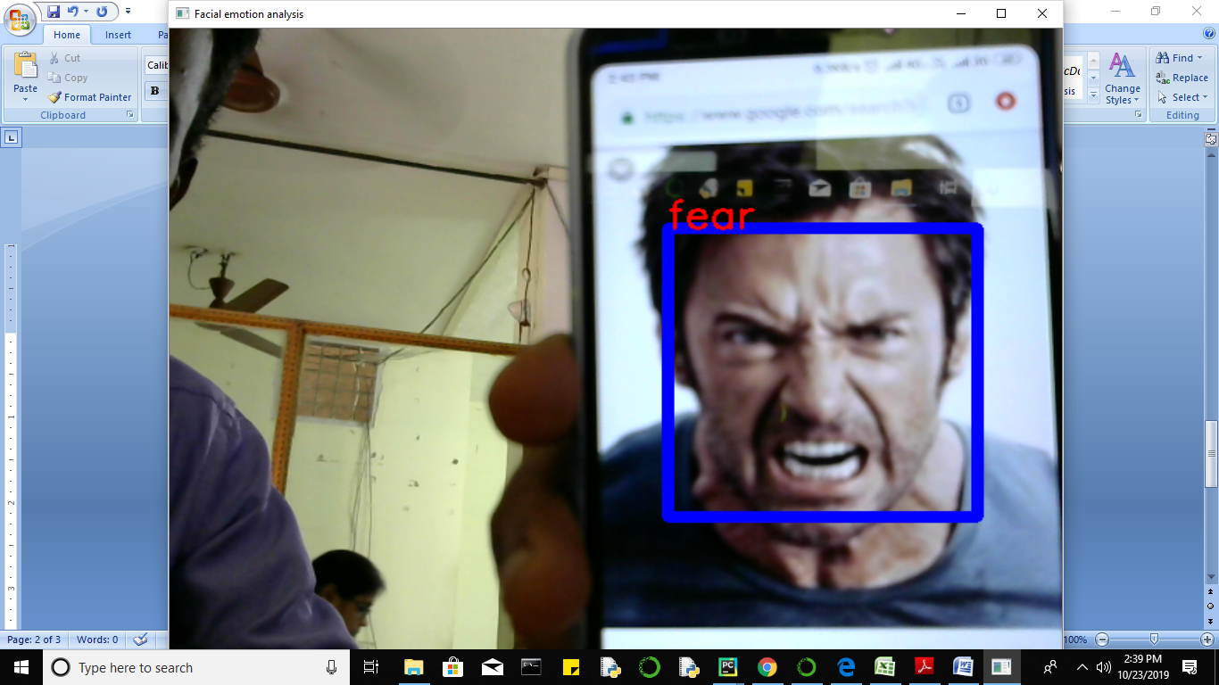

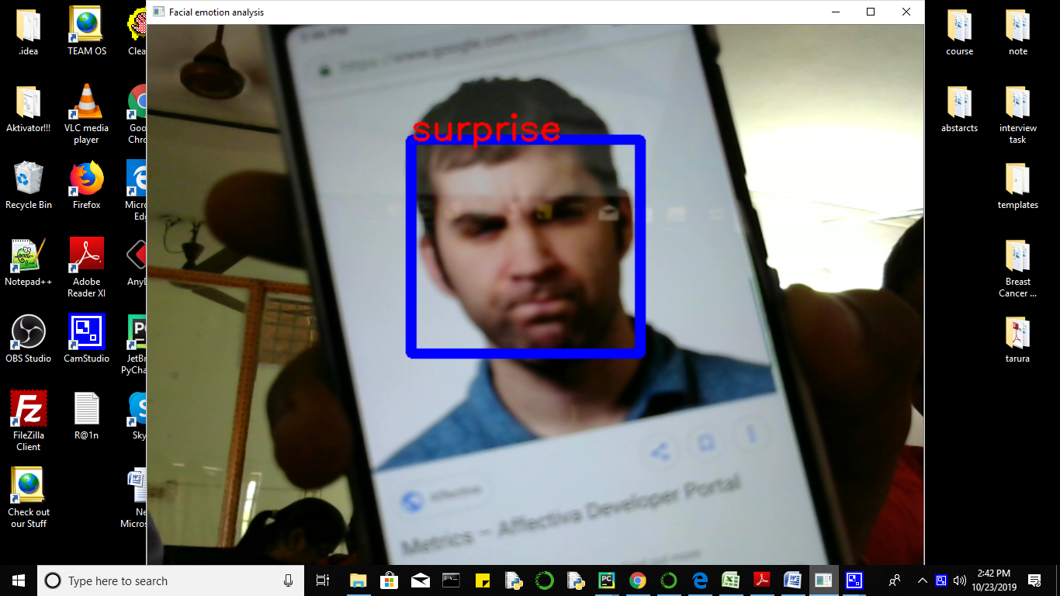

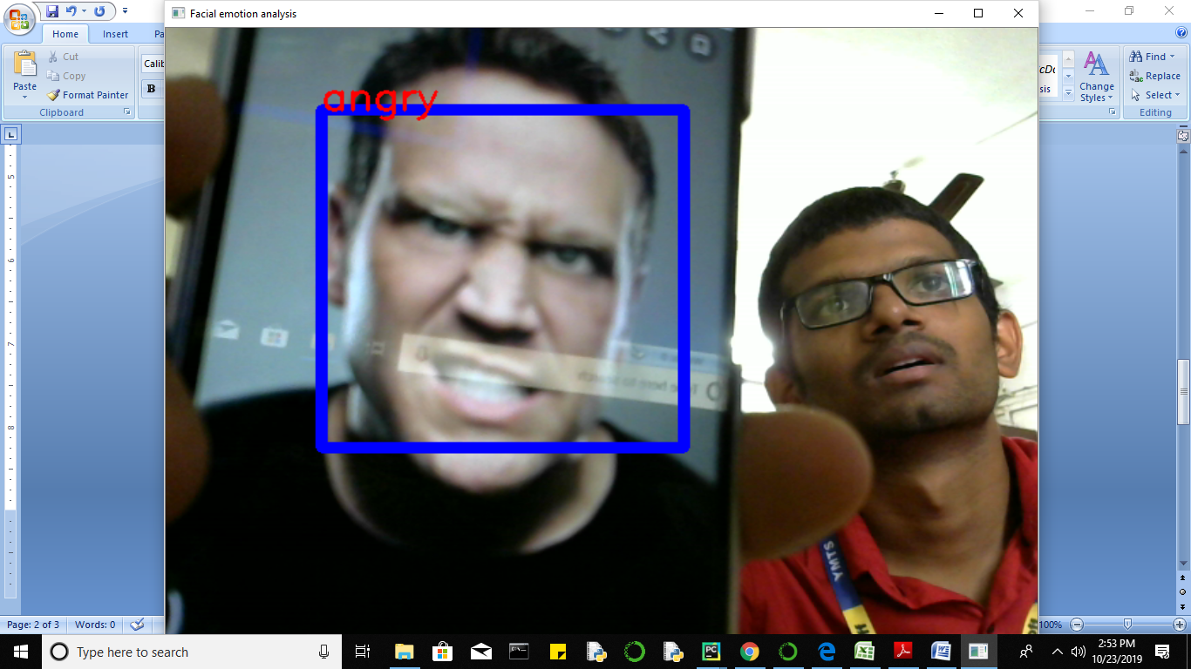

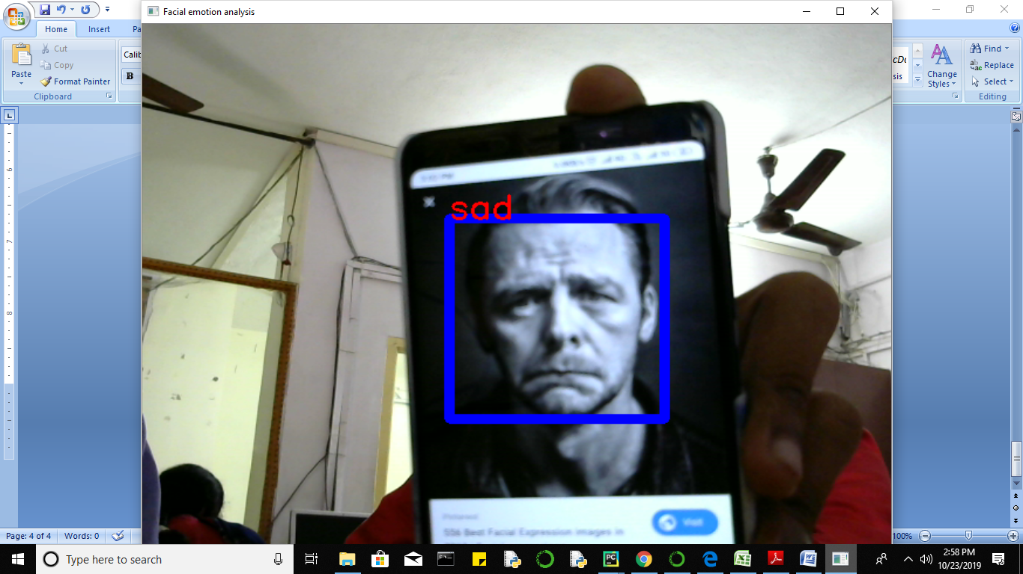

**HARDWARE & SOFTWARE REQUIREMENTS:**

# Processor : I3/Intel Processor window 7+

1. RAM :4GB (min)
2. Server side Script : Python 3.6+
3. IDE : Pycharm
4. Libraries Used : Sklearn, Pandas, NumPy, Tensor Flow, Keras